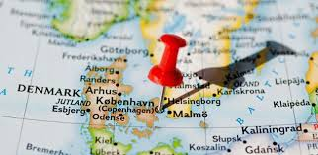

PRACTICAL INFORMATION

HOTELS

Please go hotels.com or booking.com to book, or Trivago.com – meeting venue is near Copenhagen V/the Central Station or City Hall Square. So it the restaurant for September 6.

Approx. Euro pr. Night standard room 1 person

2 stars

Cabinn 92
Wake-up 184

3 stars
Avenue Hotel Copenhagen 230
Comfort Hotel Vesterbro 250

4 stars

Hotel Skt. Annae 144
First Hotel Kong Frederik 161
Absalon Hotel 171
First Hotel Twentyseven 184
Ascot Hotel 189
The Sqaure 236

