Tour Operators Mission September 2019
Proposed Agenda

15 Sunday
Tour operators arriving from Italy
Accommodation in Hulhumale
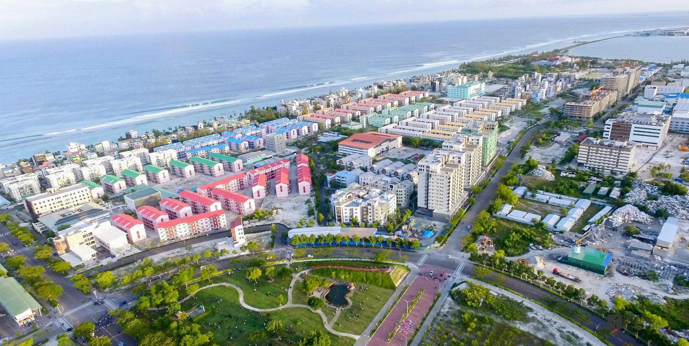
Hulhumale

16 Monday
09-1030 Opening of program – meeting officers tourism sector
11-13 visit guesthouses/meeting owners in Hulhumale
13-14 lunch with GAM board
1430-1800 visit guesthouses/meeting owners in Hulhumale
19 dinner and overnight in Hulhumale

17 Tuesday
1100 Speed boat to Thulusdoo

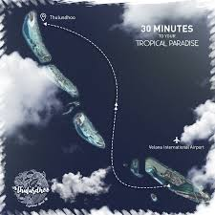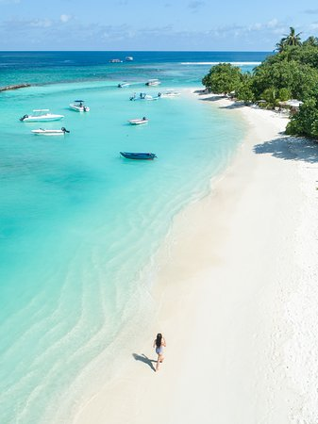
Thulusdoo

Visit guesthouses/meeting owners before lunch and in afternoon
Night accommodation in Thulusdoo

18 Wednesday
0800 Speed boat to Male (30 minutes)
Speed boat to Ukhulas (1 hour3o minutes)
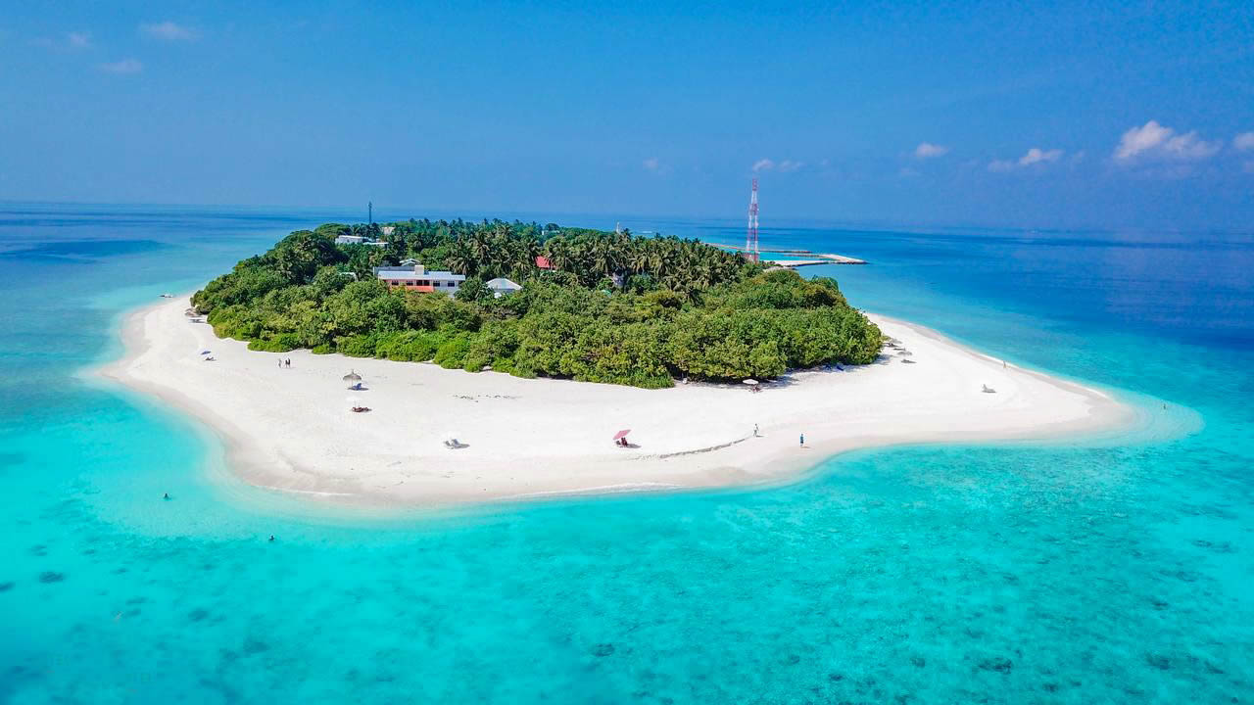
Ukulhas
Visit guesthouses/meeting owners before and after lunch
Accommodation in Ukhulas
19 Thursday
speed boat transfer to Thoddoo (1 hour)

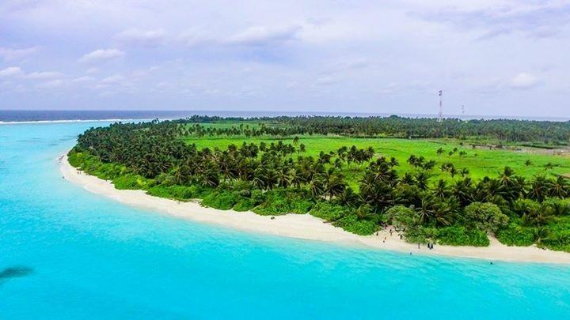
Thoddoo
Visit guesthouses/meeting owners after lunch

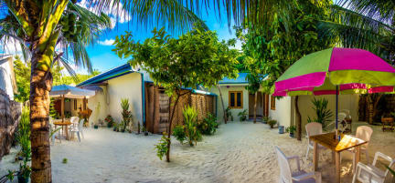

Accommodation in Thoddoo
20 Friday
Free day in Thoddoo (marine excursions will be organized for guests)

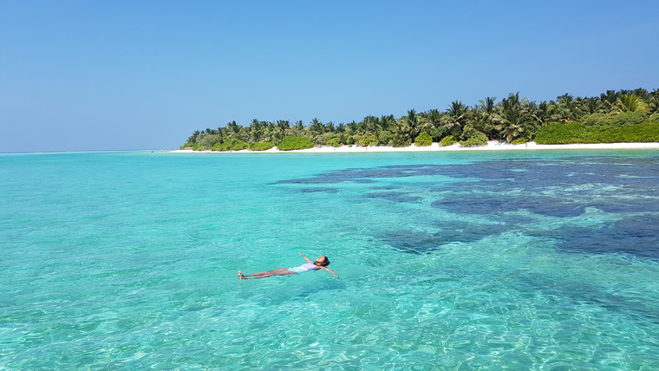
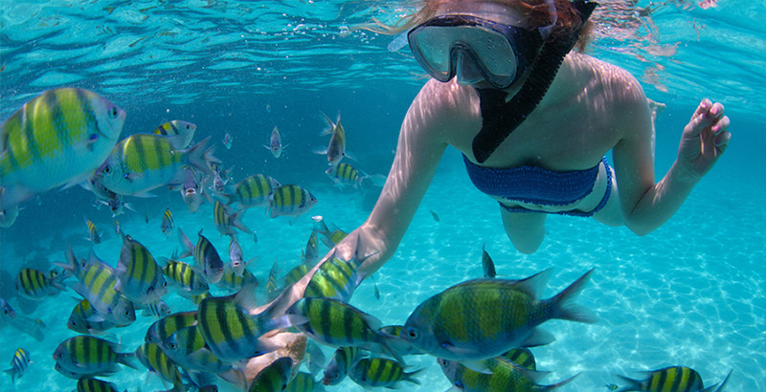
21 Saturday
Speed boat to Male
Speed boat to Maafushi (45 minutes)
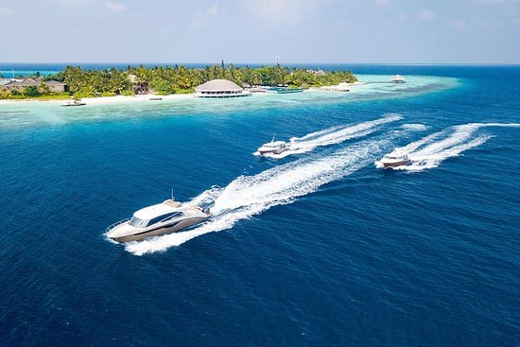
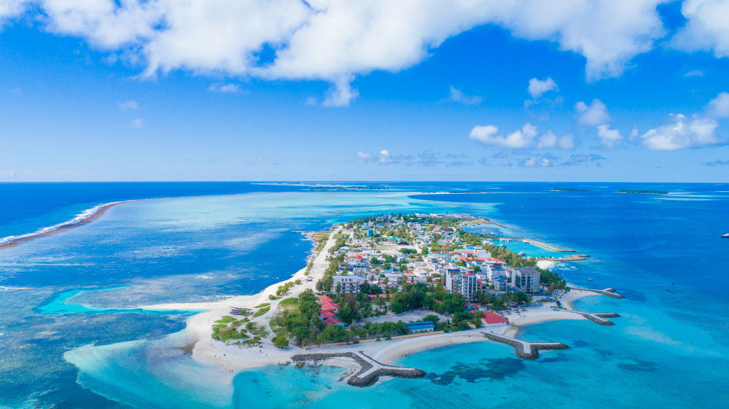
Maafushi
Visit guesthouses/meeting owners afternoon
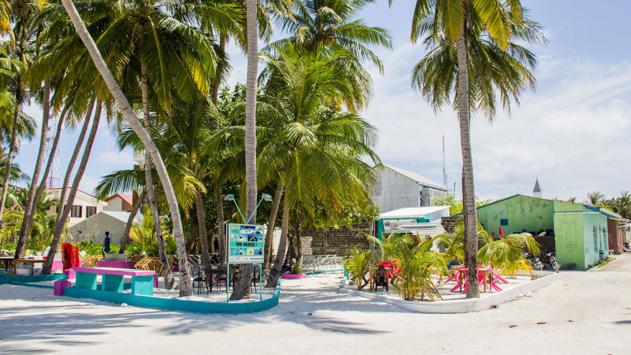
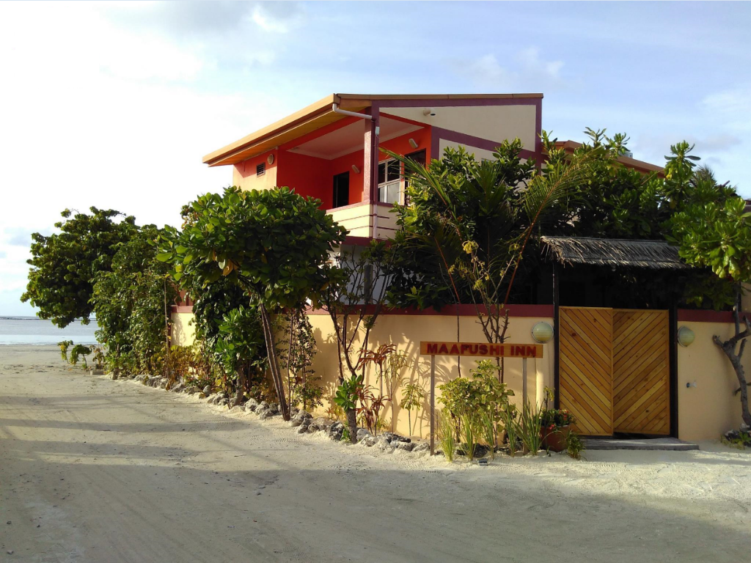
Accommodation Maafushi
22 sunday
Visit island and guesthouses/meeting owners full day

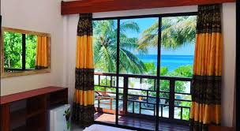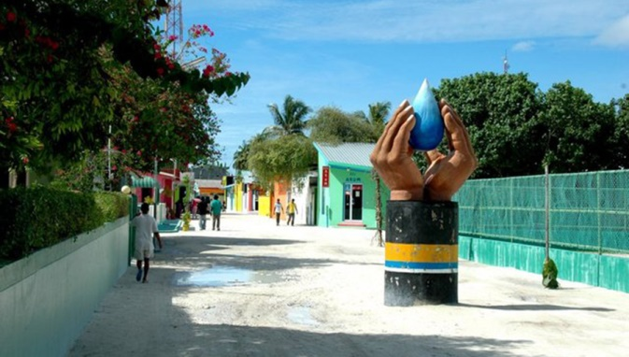
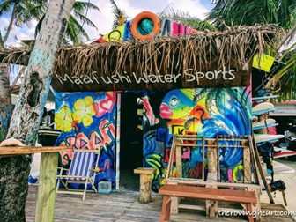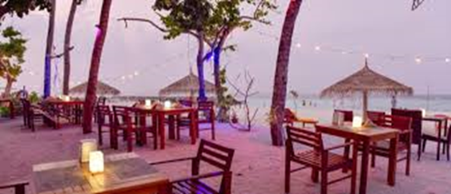
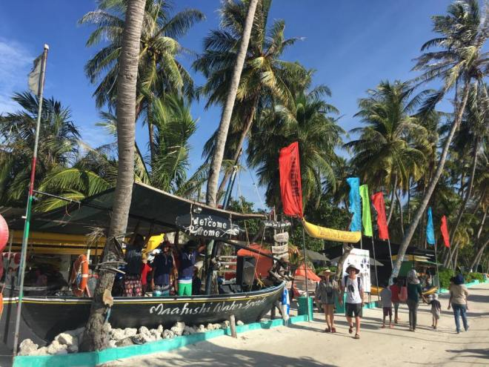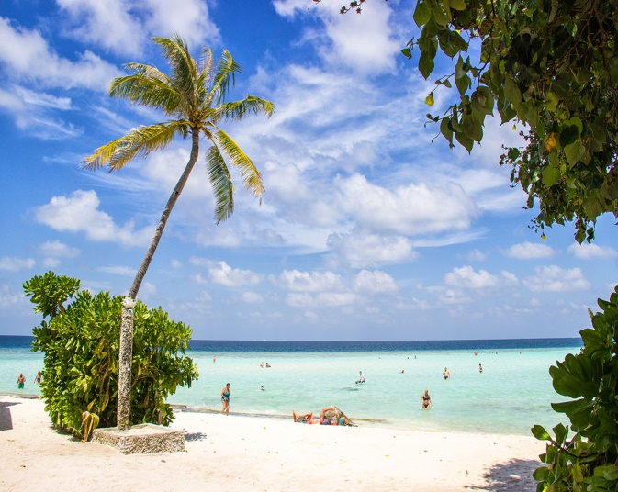
Accommodation Maafushi
23 Monday
Speed boat to Male
Final meeting with GAM
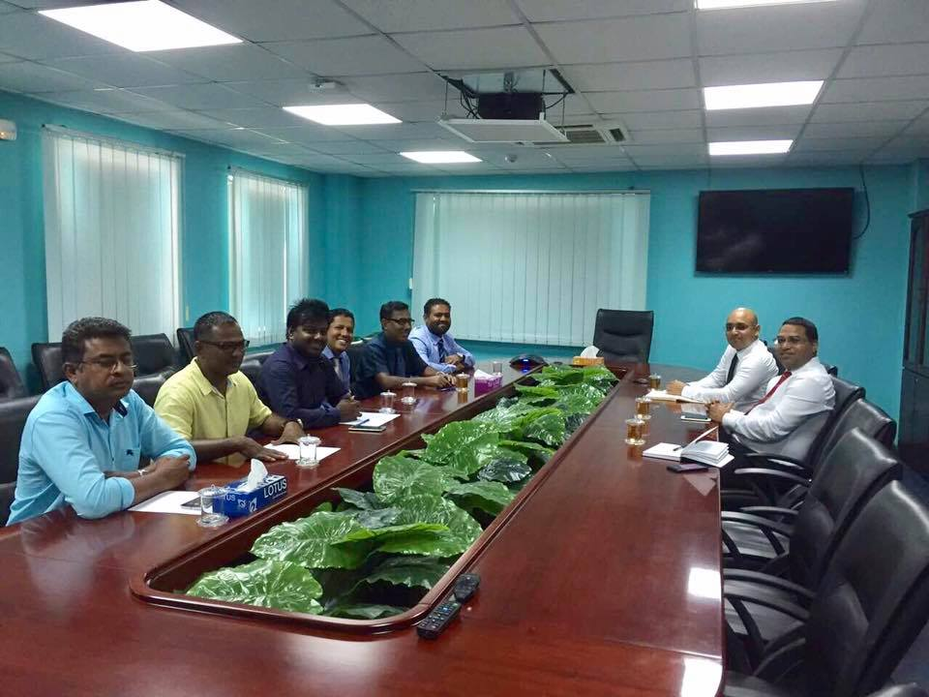
Night flight back to Italy

