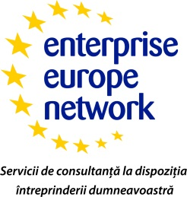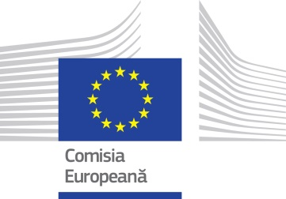

Ecomediu 2014
Brokerage for environmental protection

Arad Chamber of Commerce and Industry, in cooperation with the IPA Craiova, National institute for Research and Development for Optoelectronics and the Primom Hungary by Enterprise Europe Network organizes on October 17, 2014 starting at 11.00 international brokerage event - ECOMEDIU 2014 - targeting the areas of environmental protection, sanitation equipment, water treatment and air equipment for the collection, transport and treatment of hazardous and non-hazardous, renewable energy, research and voluntary counseling and bank financing products, etc.
The event will be hosted whitin the XII edition of the international event - ECOMEDIU 2014 and will be held in Expo Arad Complex, Pavilion B, Calea Aurel Vlaicu. 300.

Brokerage event is the organization of bilateral meetings between Romanian and foreign companies participating in the exhibition and brokerage event in an organized environment where company representatives can receive specialized care from the organizers in selecting discussion partners and service free interpretation.

Participation in the brokerage event offers a number of advantages of which the most important is contact with a large number of foreign operators in agriculture and food industry. Other advantages consist in identifying potential business partners and / or technology transfer, promoting its own as a potential business partner, internal and external market analysis, demand and supply, these elements contribute to improving the company's strategy or business plan.

To register and for more information on this event, please contact us at the coordinates:
Kranowszky Andrea Nagy, phone: 40,730,188 297 40,257,208 800,
email: andrea.kranowszky @ CCIA-arad.ro.

