Programme of the economic company mission
to Trieste and Ljubljana, Italy & Slovenia
from December 8th to 12th, 2019

Sunday, December 8, 2019

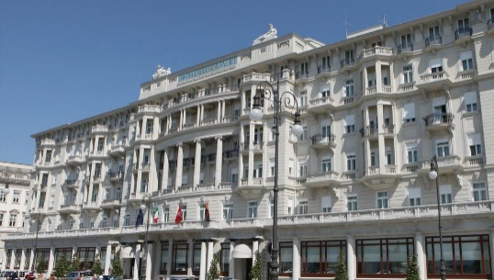
12:00 Meeting at Luxembourg Airport
13:15 Departure from Luxembourg to Trieste
with stopover in Munich
16:20 Arrival in Trieste
16:45 Transfer to the hotel and check-in

Address: Savoia Excelsior Palace Trieste - Starhotels Collezione
Riva del Mandracchio 4, 34124 Trieste, Italy
Tél: +39 040 77941
www.starhotelscollezione.com/en/our-hotels/savoia-excelsior-
palace-trieste
19:15 Departure by bus for the evening
19:45 Dinner offered by the Luxembourg Chamber of Commerce to the members of the
business delegation

Venue: Antico Caffè San Marco, via Battisti, 18
23:00 Return by bus to the hotel

Monday, December 9, 2019

08:30 Meeting in the lobby of the hotel

08:45 Transfer to the company Illycaffè

09:15 - 10:45 Visit of Illycaffè

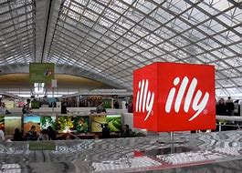
illycaffè S.p.A. is a large international company, selling its coffee-related products in approximately 140 countries worldwide. The company exclusively purchases coffee of the arabica species, in particular from Brazil, the largest producer worldwide. Illy's Università del caffè ("University of Coffee") offers free training for growers. Illy is the world's first company to receive the Responsible Supply Chain Process (RSCP) certification of sustainability.

11:00 Visit of the port of Trieste

Welcome by Mr. Zeno D’Agostino, President of the Harbour Authority of Trieste - presentation and visit of the port
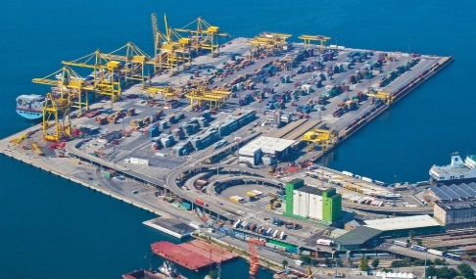
The intensification of trade and maritime traffic between the Far East and Europe and the eastward enlargement of the European Union have revived the importance of the Upper Adriatic, opening up new growth and development opportunities for Trieste. In this context, Trieste plays a decisive role in two separate supply chains: long-distance intercontinental maritime transportation and short/medium-distance intra-Mediterranean trade. The convergence of the TEN-T strategic axes of the “East Mediterranean Motorways of the Sea” with the Baltic-Adriatic and Mediterranean Corridors is resulting in the growth of intermodal services and the development of innovative solutions in the field of logistics and transportation.

13:00 Return to the hotel & free time
14:00 Economic Programme: “Italy – Luxembourg Business Forum”
Venue: Savoia Excelsior Palace Trieste

14:00 Welcome of the Invitees

14:30 Opening of the Economic Seminar & Welcome Addresses

14:50 Economic presentations: The economic characteristics of the Grand Duchy of Luxembourg
and the Region of Friuli-Venezia Giulia

15:50 Closing Remarks & Business meetings among the participants

16:00 Bilateral business meetings between Luxembourg and Italian companies

18.30 End of meetings
20:30 *** Official Dining Reception ***
Venue: Savoia Excelsior Palace Trieste

Tuesday, December 10, 2019
08:30 Check-out of the hotel
09:00 Visit of Elettra

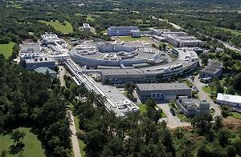
Elettra - Sincrotrone Trieste S.C.p.A. is a multidisciplinary international research center, specialized in generating high quality synchrotron and free-electron laser light and applying it in materials science.

11:15-12:45 Lunch

13:00 Departure by bus to Ajdovščina (Vipava valley) (distance Trieste – Ajdovščina 50 km)

