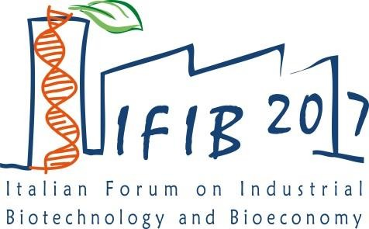

ROME, 5-6 OCTOBER 2017

PRELIMINARY PROGRAMME

THURSDAY 5TH OCTOBER

08.30 | Registration
09.10 | Introduction to the Event M. Bonaccorso (Assobiotec)
09.20 | Welcome Message S. Fantacone (President Lazio Innova)
09.30 | KEY NOTES SESSION (Chairman: F. Fava, University of Bologna)
09.30 | The role of biomass in the world bioeconomy, M. McLaughlin (BInCanada)
09.50 | The BioCycle Economy, D. Walker (Ellen McArthur Foundation)
10.10 | EU Bioeconomy Strategy - Looking ahead, T. Arnold (DG R&I EU Commission)
10.30 | Session – REGIONAL POLICIES (Chairman: C. Patermann)
10.30 | BioVale: establishing a high value waste-based bioeconomy (M. Smallwood, BioVale, UK)
10.45 | The role of regions in the Italian Bioeconomy, R. Liberali (Cluster SPRING, Italy)
11.00 | Hauts-de-France and Grand Est, France (C. Luguel)
11.15 | Rheinland Westfalen, Germany (M. Kircher)
11.30 | Policy for opportunities for the biobased economy in Zuid-Holland, M. Groen (Province Zuid Holland, The Netherlands)
11.45 | Coffee Break – Poster Session
12.15 | Session – ROUND TABLE Shared Pilot Facilities: the Experience of European Smart Pilots  (Chairman: C. Patermann)  Panelists: Ilaria Bonetti (Innovhub-SSI), Peter Flippo (Bioprocess Pilot Facility, The Netherlands), Brecht Vanlerberghe (Bio Base Europe Pilot Plant, Belgium), J. Mena Sanz (CLAMBER R&D Biorefinery, Spain)
13.15 | Networking Lunch – Poster Session
14.30  16.00 | Session - BIO-BASED INDUSTRIES  (Chairperson: G. Sannia, University of Naples Federico II, L. Gardossi, University of Trieste) (each presentation is scheduled to last 10 minutes)  Bioeconomy in Poland: open opportunities, S. Bielecki (Technical University of Lodz, Poland)  From Novamont Group, Mater-Biotech: a flagship plant for bio-bdo production, G. Gregori, (Mater Biotech, Italy)  Whisky, Wood and Water: designing a bioeconomy with what you have to hand, P. Hudman (IbioIC, Scotland)  How Industrial Biotechnology can contribute to Circular Economy: some examples, J. Velasco, (Neol Bio, Spain)  Development and scale-up of fermentation processes for the manufacturing of microbial enzymes and biochemicals, M. Pistocchi (Biosphere, Italy)  Policy strategies for sustaining European transition towards a bio-based economy, E. Imbert (University of Rome La Sapienza, Italy)  BBI JU: TWO SUCCESS CASES  The AgriMax approach to the agri-food waste valorisation, G. Belotti (IRIS, Spain)  BBI DEMO project GRACE – Scope, aims and challenges, A. Kiesel (University of Hohenheim, Germany) | IFIB 2017 Brokerage event – 1st slot
16.30 | Coffee Break – Poster Session
17.00 | Fourth Session – ENERGY AND BIOREFENIRIES  (Chairwoman: G. Speranza, University of Milan) (each presentation is scheduled to last 10 minutes)  From dedicated crops to food waste valorization: different models of biorefinery, N. Ravasio (CNR, Italy)  From carbohydrates to hydrocarbons, M. Delcourt (Global Bioenergies, France)  The Green Refinery Project, G. Rispoli (ENI, Italy)  The role of advanced ethanol fuel in the context of the post-2020 Renewable Energy Directive,  S. Cobror (BioChemtex, Italy)  NexSteppe Sorghum - A Global Feedstock for the Global Bioeconomy Anna Rath (NexSteppe, USA)  Bioenergy in Western Macedonia, Y. Fallas (West Macedonia Bioenergy and Environment Cluster, Greece) | IFIB 2017 Brokerage event – 2nd slot
18.30 | Conclusion

FRIDAY 6TH OCTOBER

08.30 | Registration
09.00 | Success projects elevator pitches
10.15 | Session – CIRCULAR ECONOMY (Chairman: Massimiano Tellini, Intesa Sanpaolo)(each presentation is scheduled to last 10 minutes) | IFIB 2017 Brokerage event – 3rd slot
 | Converting waste/wastewater organic matter into valuable bio-based products: 3 pilot-scale studies in the H2020 Programme, M. Majone (University of Rome La Sapienza, Italy)
 | Bioeconomy in the Czech Republic: Adopting the Circular Economy, G. Sakellaris (University of South Bohemia, Czech Republic)
 | BioFutureFactory as it operates according circular economy principles, J. Kantola (KaiCell Fibers, Finland)
 | Circular Bioeconomy: how to have people on board. The experience of Greece, C. Vorgias (University of Athens, Greece)
11.15 | Coffee Break – Poster Session
11.40 | Sessione – LIFE SCIENCES (Chaipersons: D. Ubiali, University of Pavia, S. Riva, CNR) | IFIB 2017 Brokerage event – 4th slot
 | Beyond medicine to deliver innovative, holistic health care solutions to patients, I. Di Schiena (Abbvie, USA)
 | Research and Innovation in the Biomedicine, A. Pellacani (Menarini, Italy) tbc
 | Biosimilars: sustainability of the Healthcare system at the service of innovation , A. Tosco (Finox Biotech, Switzerland)
 | The development and manufacturing of anticancer drugs with high potency and cytotoxic characteristics for the pharmaceutical industry (tbc), G. Salciarini (BSP Pharmaceuticals, Italy)
 | Genetic Cancer Vaccines: present and future perspectives, L. Aurisicchio (Takis Biotech, Italy)
13.30 | Networking Lunch

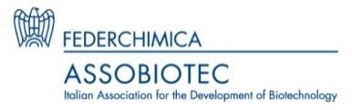
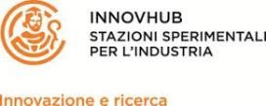
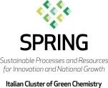
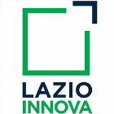

Media partners:
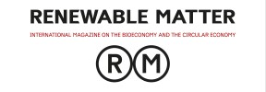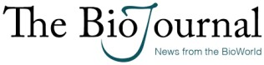

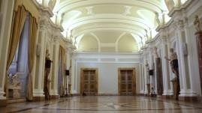
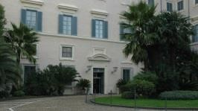
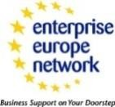
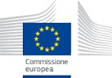
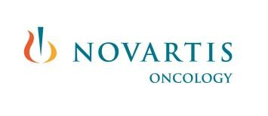
Supporting partners:
We are pleased to invite you to join us at the Italian Forum on Industrial Biotechnology and Bioeconomy scheduled on 5-6 October, 2017
LOCATION OF THE EVENT
October 5-6 IFIB 2017, at Centro Congressi Rospigliosi, via XXIV Maggio 43, ROME
Register at: www.b2match.eu/ifib2017 LANGUAGE: ENGLISH
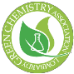
Sponsored by

IFIB 2017 Rome (5-6 October)
www.b2match.eu/ifib2017

