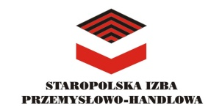
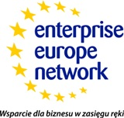

METAL 2022- an international hybrid brokerage event focused on technologies for metal processing
September 21-22, 2022
Agenda

Wednesday, 21 September
10:00-15:00 on-site bilateral meetings

Thursday, 22 September
10:00-15:00 virtual B2B bilateral meetings

