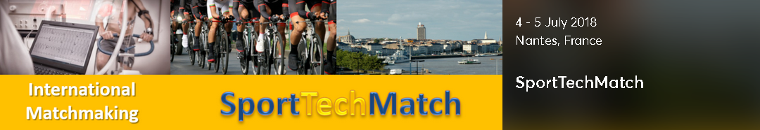

Science & Cycling conference and SportTechMatch 2018

4-5 July 2018

  - Faculty of sport sciences, Université de Nantes (UFR STAPS)
  - Nantes, FRANCE

Science contributions to development of (professional) cycling
An international conference in conjunction with the start of the Tour de France.
During the conference experts from the competitive cycling world and scientists will exchange the latest research and experiences. Alongside the conference an experience square will be set up in which companies and institutes can give demonstrations of their products and technologies.
The participants will consist of researchers, doctors, nutrition experts, sports directors, cycling organisations, trainers and cyclists/triathletes. The conference aims to get also contributions from other sport disciplines all with the objective of learning and sharing experience.
The Steering Committee will invite keynote speakers to share their views with the audience and experts from all over the world are invited to present their work in the conference.

Conference programme
The technical program will be guided by a steering committee of leading experts with the objective to deliver a high quality technical program. There are 4 categories: Keynote presentations, special presentations, oral presentations and poster presentations. The exact time schedule will be available under the header “program” in the menu as soon as the program has been composed.
The list of Keynote speakers can be found under the header “keynotes” in the menu program.
Poster presentations can be found under the header “poster presentations” in the menu program
The list will be updated almost every day due to reviewing of papers being in full process. We expect around 60 presentations in the program.

CONFERENCE WEBSITE: http://science-cycling.org/.

Planned topics
Training methods & technology
Performance analysis & translation
Data acquisition, analysis & technology
Coaching: Methods & technology
Mental support methods & strategy
Physiological Mechanisims: Analysis, adaption & tapering
Rider Health: Injury Prevention, monitoring & coaching
Medical Monitoring & Coaching
Medical issues (Cardiac control, concussions, facial injuries etc.)
Injury treatment and recovery methods
Developments in Nutrition
Aerodynamics
Bike fitting
Bike Technology

SportTechMatch matchmaking event
During the conference a matchmaking event will be organised by the Enterprise Europe Network. Companies, researchers and technologists will be offered a chance to meet potential foreign partners active in the field of cycling and other sports technologies. In pre-arranged face-to-face meetings they will have a chance to establish profitable new cooperation opportunities in business, technology transfer and research & development. Participants will have the opportunity to publish cooperation profiles on this website and to send and receive cooperation requests. On the basis of accepted requests b2b meetings will be scheduled which will take place during the conference.

Matchmaking agenda

Wednesday, July 04, 2018
12:30 - 17:30 h.

Thursday, July 05, 2018
12:30 - 17:30 h.

Company profile
It is important to create a strong profile as this will be your advertisement to attract potential partners. As the profiles will be visible before and even after the event the SportTechMatch website will serve as a marketplace.
To register and set up a profile for the SportTechMatch follow this link:

SPORTTECHMATCH WEBSITE: SportTechMatch Nantes 2018

Important: Participants in the SportTechMatch need to register for the Science & Cycling Conference as well. The conference is NOT free of charge.
More information on the conference and an overview of registration fees and services linked with different types of registration is available on the conference website.

Contact

Mr. Stan Francke
Enterprise Europe Network Netherlands
E stan.francke@rvo.nl
T +31 – 88 042 52 59
Or contact your local office:
https://sporttechmatch2018nantes.b2match.io/page-901

