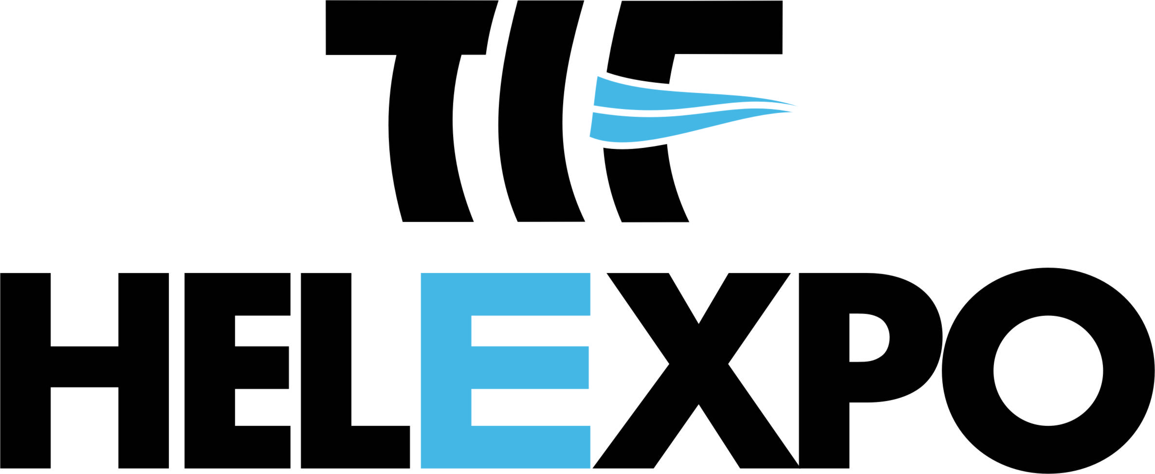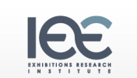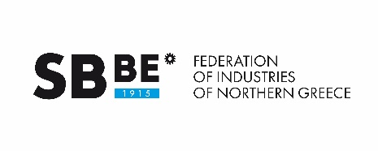

HOSTED BUYERS PROGRAM: Fix your appointments, NOW!

WHAT IS IT?
It is a service provided by HELEXPO to exhibitors and visitors, based on the promotion of co-operation among businesses, through pre-arranged business meetings. Companies participating in HELEXPO exhibitions will have the opportunity to meet exhibitors, thanks to a customized software program, where business meetings can be pre-arranged within the exhibition area. This is achieved through a state-of-the-art electronic system.

WHY SHOULD YOU PARTICIPATE?
- You ensure your business meetings (face-to-face) with companies of your choice
- You have better control of the time spent at the Fairgrounds
- You open new business opportunities
- You get acquainted with products and services which are 100% relevant to your business activities
- You find the appropriate colleagues in your field
- You exchange knowledge in your business area of interest
- You arrange your appointments according to your needs.

HOW TO REGISTER
- You must fill in the forms : “Trade Visitor’s Requested Data” and “Co-operation Profile”
- The completed forms must be sent to the Enterprise Europe Network office of the Federation of Industries of Northern Greece (FING) at: m.nagy@sbbe.gr
- An initial evaluation of your application will be made by FING, followed a final assessment by HELEXPO. Please note that a first-come-first-served order will be applied for all applications.
- If accepted as a Hosted Buyer, you shall receive a User Account from HELEXPO as well as instructions on how to proceed with the pre-arrangement of your appointments with our exhibitors, through our on-line B2B Program. A minimum of 15 appointments per Hosted Buyer is a prerequisite for the final confirmation of your participation in the Program. Furthermore, HELEXPO maintains the right to additionally arrange appointments for you, according to your fields of interest and our exhibitors’ requests.
- Your accommodation and/or flight arrangements will be arranged by HELEXPO.
- Your transfer from and to the airport, as well as from the hotel to the exhibition venue and back, will be arranged by HELEXPO.
- In case of non confirmation of your visit (hotel & air ticket) and your B2B appointments, at the latest ten days prior to the opening of the exhibition, your participation in the Hosted Buyers Program will automatically be cancelled (as will also be the case for your air-ticket and hotel bookings)
- If you require an Invitation Letter for entry visa purposes, HELEXPO will provide it to you, as long as you inform them two months prior to the exhibition. In case you already have an entry visa, you shall be requested to send a copy to HELEXPO together with your completed forms.
- Printed material as well as your entrance badge will be available at your hotel, upon arrival.
- FING and HELEXPO staff will provide any necessary assistance and information to you during your visit at the exhibition.
- Before leaving the exhibition, you shall be asked to fill in a feedback questionnaire about your visit.

Take advantage of the opportunity HELEXPO is offering free of charge, to ensure successful business contacts and partnerships, combining work with pleasure and added value services, in a rich and hospitable exhibition environment. Further details on your visit will be sent to you in due time.

We wish you every success in your business transactions and are looking forward to welcoming you to FRESKON 2017!

